**Steps to run search engine**

Ensuring that all files of the downloaded folder remain in the same folder.

1. Open the folder Search Engine Project using Visual Studio or any software you like
2. Open the folder Final Search_Engine_Project which is inside Step 1.
3. Open the folder 5 Web_Search_Engine_using_Database which is inside Step 2.
4. Open MySQL and run the script My_Custom_Bot2
5. Run the python script “search_terms.py” which is inside step 3.
6. Come back to MySQL and run the following commands in MySQL:
7. SELECT * FROM MY_CUSTOM_BOT.searches;
8. SELECT * FROM MY_CUSTOM_BOT.search_results_v2;
9. Run the “websearch.py” python source file making sure that other attached files are in the same directory “5 Web_Search_Engine_using_Database”.
10. Copy the URL obtained in terminal after completing step 7.
11. Paste it in the browser and run. Change the search terms in order to get order of different URLs.

**DEMO**

**[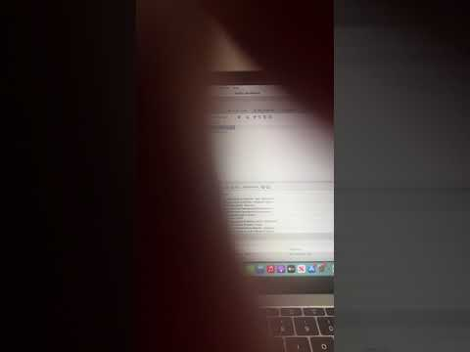](https://www.youtube.com/embed/Ax7p3e7vcDM?feature=oembed)**